**Coursera Capstone Project**

**IBM Data Science Professional**

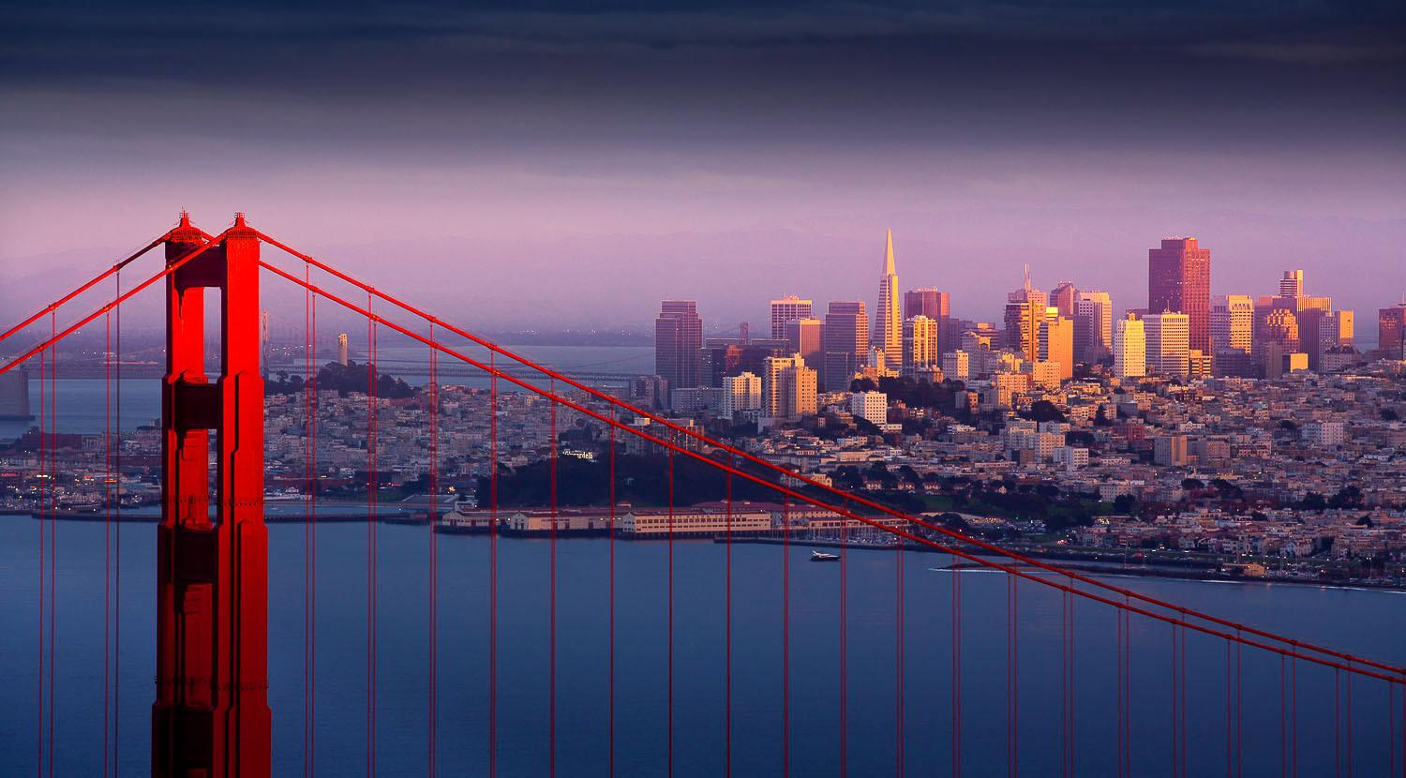

**New Movie Theaters in San Francisco, California**

**By: Kyle Tran**

**August, 2019**

**Introduction/ Background**

Movie theaters have become an integral part of the way people live since 1905. The first theater originated in Pittsburgh, Pennsylvania, and it revolutionized the way we spend our free time around the world. Short silent films eventually evolved into the motion pictures, which led significant advancements in film production became the foundation in many technological equipments and techniques that are being used today. As the popularity of movies increased the market, companies began to invest money into expanding more locations around the world. The idea of choosing the proper location for a business is time-consuming, stressful, and tedious. A company needs to know the amount of foot traffic, competitors, and etc. in order to ensure the success and future of the business. Owners need to know the location of movie theaters in order to separate themselves from others. The goal of opening a new movie theater is to avoid nearby competition and increase the amount of foot traffic, but it is hard to research which area in San Francisco would be acceptable as the location

**Business Problem**

The purpose of my capstone project is to examine which locations in San Francisco, California would be fit to open a movie theater.

**Question:**

Which area in San Francisco, California would be recommended for project developers to open up a new movie theater?